Data Visualization for Digital Health

**Report Topic**: **Heart Rate and Sleep Quality Analysis with BMI Categories**

1. **Introduction**

This report examines the relationship between heart rate, sleep quality, and Body Mass Index (BMI) categories using a simulated dataset. Understanding these relationships is crucial for identifying potential health risks linked to cardiovascular health and sleep disorders.

**1.1 Objectives**

• To analyze how heart rate varies with different levels of sleep quality.

•To explore variations in these patterns across different BMI categories

**1.2 Dataset Description**

There was a data collection on variables like sleep duration, gender, age, quality of sleep, BMI category, heart rate, through which I made an analysis on to know how sleep quality correlate with heart rate and BMI category. Find below is a sample of the collected data.

* **Heart Rate**: Measured in beats per minute (bpm).
* **Quality of sleep**: Rated on a scale from 1 to 10.
* **BMI Categories**: Classified into Underweight, Normal weight, Overweight, and Obese based on their calculated Body Mass Index. using a simulated dataset

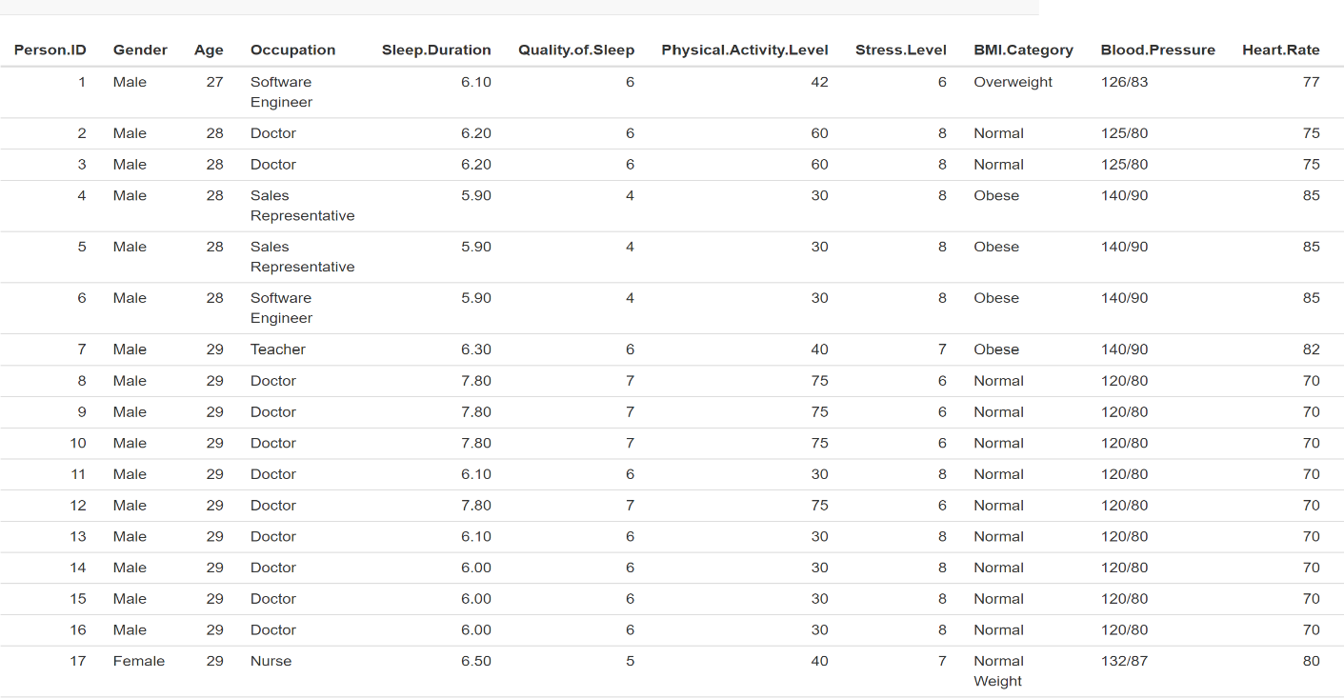

Fig 1. Sample of collected data

**2.0 Data Analysis and Findings**

Through data analyzing and visualization, I observed that lower quality of sleep has a significant impact on higher heart rate. Higher quality of sleep with the scale from 6-10 have a heart rate value ranging from 65bpm to 75bpm.

Furthermore, BMI category also has an impact on heart rate as shown in Fig 2. Almost all of the people under obese category have heart rate not lower than 80bpm, irrespective of their sleep quality. A person overweight and having a lower quality of sleep has higher heart rate and the vice versa.

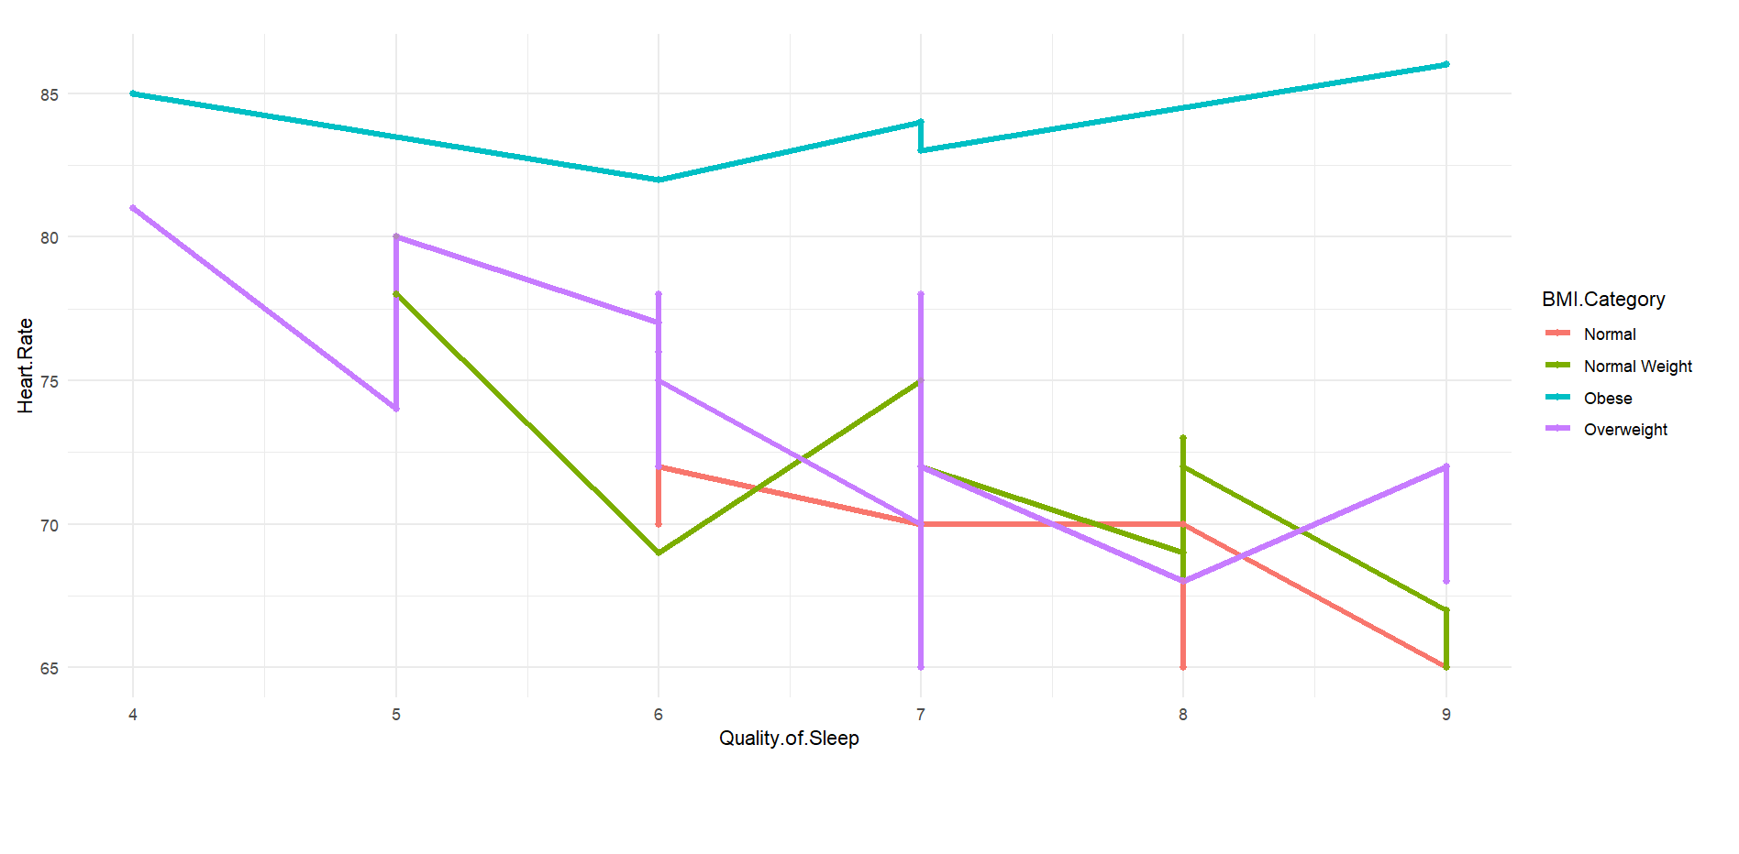

Fig 2. Data visualization

**3.0 Conclusion**

Through this analysis and visualization efforts:

* Impact of Sleep Quality: Higher self-reported sleep qualities correlate with lower average resting heart rates across varying BMI classifications. This indicates that improved sleeping conditions may enhance cardiovascular health outcomes.
* Health Implications: These findings underscore the importance of monitoring both sleeping patterns and body composition when assessing cardiovascular risk factors.